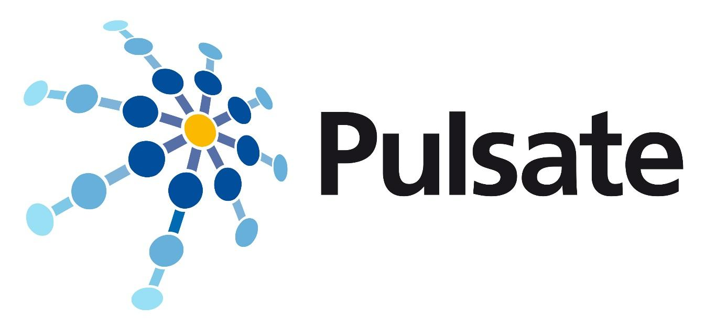

Call Announcement
Adopters’ Use Cases
1st Open Call

(1st edition 2022)

Open date for proposals: 24 January 2022 at 00:00 CET (Brussels Time).
Deadline: 31 March 2022 at 17:00 CEST (Brussels Time).
Version 1: 15/12/2021

This project has received funding from the European Union’s Horizon 2020 research and innovation programme under grant agreement No 951998. PULSATE is supported by the Photonics Public Private Partnership. | 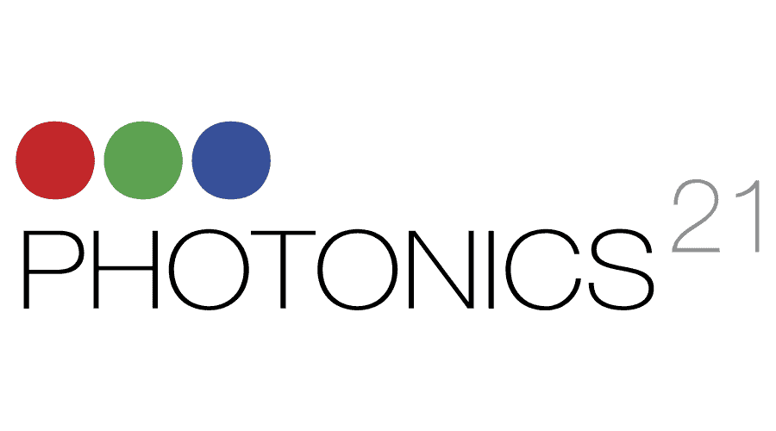

The information contained in this report is subject to change without notice and should not be construed as a commitment by any members of the PULSATE Consortium. The information is provided without any warranty of any kind.
This document may not be copied, reproduced, or modified in whole or in part for any purpose without written permission from the PULSATE Consortium. In addition to such written permission to copy, acknowledgement of the authors of the document and all applicable portions of the copyright notice must be clearly referenced.
© COPYRIGHT 2020 The PULSATE Consortium.
All rights reserved.

Announcement for PULSATE Adopters’ Use Cases Open Call

Call title: | 1st Open Call for Adopter Use Cases (Laser-Based Advanced and Additive Manufacturing)
Full name of the EU funded Project: | Fostering the PAN-European infrastructure for empowering SMEs digital competencies in laser-based advance and additive manufacturing
Project acronym: | PULSATE
Grant Agreement number: | 951998
Call publication date: | 24 January 2022 at 00:00 CET (Brussels Time)
Call deadline: | 31 March 2022 at 17:00 CEST (Brussels Time)
Expected duration of the activities (i.e. PULSATE Support Programme): | 3 months
Number of proposals to be funded: | up to 21
Total EU funding available in this Open Call: | 525.000 EUR
Maximum funding request per Adopter SME/Slightly Bigger company: | Up to 25.000 EUR
Submission & evaluation process: | Applications must be submitted via https://pulsate-adopters.fundingbox.com.  The selection of the open call proposals will be carried out in a four-step process:  - Step 1 will check the proposals against eligibility criteria.  - Step 2 will involve external evaluation to assess the proposal according to the criteria.  - Step 3 will involve the PULSATE consortium to prioritise the proposals based on the external evaluation results and the objectives of the PULSATE project.  - Step 4 legal check before finalists are invited to sign the Sub Grant Agreement.  For further information see the Guide of Applicants section 4.
Applicants eligibility: | PULSATE is looking for End-user/Technology Adopter companies that are interested in the implementation of LBAAM technology into their environment that will enhance the activities of the manufacturing industry.  Adopters should represent high-potential business Use Cases for implementation of Laser-Based Advanced and Additive Manufacturing (LBAAM) technology in their processes, products and business models.  Applications can be submitted by only ONE company that has the status of SMEs or a Slightly Bigger company. and is legally established in one of the eligible countries.  For further information see the Guide of Applicants section 3.
Further information: | - Main Open Call and application website where all documents can be found: https://pulsate-adopters.fundingbox.com  - Helpdesk email: pulsate.help@fundingbox.com  - PULSATE website for general information about the project: https://www.pulsate.eu/  - PULSATE Community (Open Call Helpdesk)
ABOUT PULSATE
PULSATE is a part of the Horizon2020 programme called I4MS funded by the European Commission with the goal to accelerate the design, development and uptake of advanced digital technologies by the European Manufacturing industry to empower personalised products and to facilitate cost-effective small-scale production.
One of these digitalization technologies that PULSATE project is focused on is Laser-Based Advanced & Additive Manufacturing (LBAAM). To boost and support the uptake, PULSATE will select and support end-users (Adopters) SMEs and Slightly bigger companies that are willing to implement Laser-Based Advanced & Additive Manufacturing (LBAAM) technologies into their environment.
To enable this, PULSATE project brings together a strong consortium comprising six competence centres (AIMEN, FTMC, MTC, SINTEF, Fraunhofer and CEA) with high-level expertise in LBAAM and digitisation, the European Photonics Industry Consortium (EPIC) to support the acceleration of EU innovative scale-up initiatives, and two highly innovative SMEs (CLESGO & Fundingbox) to establish and support the Digital Agora platform, maintain a Marketplace of digital services and to manage the mechanisms of financial support to selected companies and the connection with DIHs across all Europe.
Through the 1st Open Call for Adopters, PULSATE will select up to 21 Adopter SMEs/Slightly Bigger companies that represent high-potential business use cases for implementation of LBAAM technology in their processes, products and business models.
Selected Adopters will take part in a 3-month support programme between 09 - 11.2022 through which they will receive:
● Up to 25 000 Euro as a lump sum
● Mentorship from PULSATE Consortium partners in LBAAM feasibility assessment that will allow Adopters to confirm Technical and/or Business Feasibility for the implementation of LBBAM technology in their environment.

